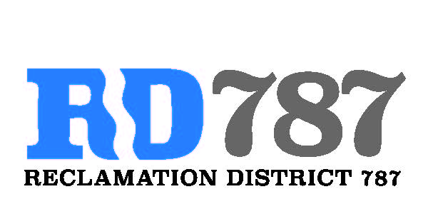

41758 County Road 112. Knights landing CA. 95645. Ph: 530 735-6274. Fax: 530 735-6734

**Minutes of the Board Meeting**

**July 31st, 2019**

**4:30 pm**

1. Call to Order – 4:30 pm President Roger Cornwell called the meeting to order

* Present were:

Board Members: Roger Cornwell, Joseph Hutchins, (Eric Faye – Absent)

Attorney: None

Public: None

1. Approval of Agenda for July 31st, 2019
   * Additions to Agenda – no additions to the agenda

* Joseph Hutchins made a motion to approve, second Roger Cornwell – motion passed unanimously

1. Open Public Forum – None members present
2. Approval of Minutes from April 8th, 2019 Board Meeting

* Joey Hutchins made a motion to approve the minutes, second Roger Cornwell. Motion passed unanimously

1. Approval of Resolution NO. 19-10 – Requesting FMAP funding for the Fiscal Year 2019-2020 and Authorizing the Chairman to execute FMAP Funding Agreement for the Fiscal Year 2019-2020.
   * Joey Hutchins made a motion to approve the Resolution No. 19-10, second Roger Cornwell. Motion passed unanimously
2. Approval of Resolution NO. 19-11 – Accepting FMAO funds (Exhibit E of the attached Funding Agreement).
   * Joey Hutchins made a motion to approve the Resolution NO. 19-11, second Roger Cornwell. Motion passed unanimously
3. Chairman Cornwell gave an update on FMAP funding expenditures to the board. Increase in trash and debris pickup, increase amount of oat seeding in will done in November. Also burning and increase slope work has occurred over the last month.
4. Notice of Election and Nominating Petitions for the Office of Trustee, Reclamation District 787.
   * Joey Hutchins made a motion to approve the Notice of Election and Nominating Petitions, second Roger Cornwell. Motion passed unanimously
5. Approval of Resolution NO. 19-12 – Resolution calling for an all mailed ballot election.
   * Joey Hutchins made a motion to approve the Resolution NO. 19-12, second Roger Cornwell. Motion passed unanimously
6. Adjourn meeting was adjourned at 4:58 pm