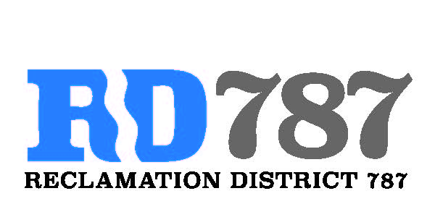

41758 County Road 112 . Knights landing CA . 95645 . Ph: 530 735-6274 . Fax: 530 735-6734

**Notice of Special Meeting Agenda Board of Directors Reclamation District 787**

**Wednesday, December 28.2022**

**10:00 Am**

1. **Call to Order**
   1. ***Called to order 10:00***
2. **Public Comment** 
   1. ***none***
3. **Inspections report – Dominic Reported 10:09**
   1. **Canpile pump repairs 2023 – *advised that one pump is having issues and is bound up***
   2. **Canpile meter project completion – *report on completion of watersmart 2020 grant work and now finalize project***
4. **Resolution 2022-2 – *resolution to accept FMAP 2023 Maintenance Funding from DWR***

* ***Eric made motion to accept – authorize Dominic to Sign***
* ***Roger second***
* ***Approval unanimous***

**No further discussion**

1. ***Any Additional Business – none***
2. ***Adjourn 10:11***

**In attendance**

**President – Roger Cornwell**

**Trustees – Eric Faye and Dominic Bruno**