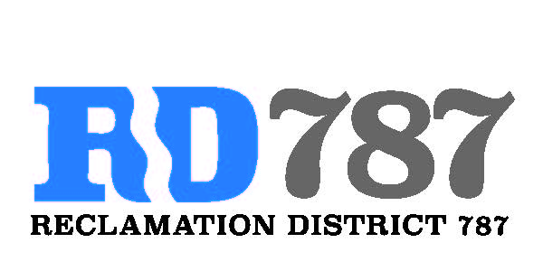

41758 County Road 112. Knights landing CA. 95645. Ph: 530 735-6274. Fax: 530 735-6734

**Board Meeting**

**April 20th, 2020**

**10:00 am**

**MODIFIED BROWN ACR PROCEDURES IN LIGHT OF COVID-19**

In compliance with CA Executive Orders N-25-20 and N-29-20, members of the Board of Directors and members of the public are suggested to participate in this meeting via teleconference/webinar. During this period of modified Brown Act Requirements, the District will use best efforts to swiftly resolve requests for reasonable modifications or accommodations with individuals with disabilities, consistent with the Americans with Disabilities Act, and resolving any doubt whatsoever in favor of accessibility.

1. Call to Order.
2. Approval of Agenda April 20th, 2020.
3. Open Public Forum.
4. Approval of Minutes from February 5th, 2020 Board Meeting, and March 3rd, 2020 Special Board Meeting.
5. Approve Resolution 20-02, Notice of Exemption for Maintenance.
6. Approve Resolution 20-03, Resolution Accepting FMAP 2021 Funding.
7. Adjourn.