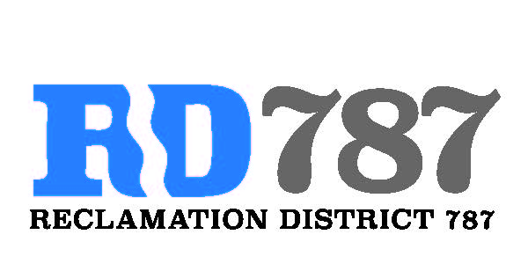

41758 County Road 112 . Knights landing CA . 95645 . Ph: 530 735-6274 . Fax: 530 735-6734

**Notice of Special Meeting Agenda Board of Directors Reclamation District 787**

**Tuesday, June 6, 2023**

**10:00 Am**

1. **Call to Order**
2. **Public Comment**
3. **Winter 2022-23 disaster work and FEMA** 
   1. **Resolution 2023-1 – OES-FPD-130 – Designation of Authorized agent requires board action**
   2. **OES-FPD-012 -List of people to be in the loop for feds**
   3. **OES-FPD-089- assurances for federal assistance**
4. **Any Additional Business**
5. **Adjourn**

**Meeting In Person at 787 Office – 41758 County Road 112, Knights Landing CA 95645**

**Remotely :**

Microsoft Teams meeting

[Click here to join the meeting](https://teams.microsoft.com/l/meetup-join/19%3ameeting_YzU2MjQzYzQtZGZmOS00ZWYwLTg1OTMtM2I3Y2U2YzQ4NTBk%40thread.v2/0?context=%7b%22Tid%22%3a%22c8a2d4fb-dda7-4084-ab00-bcb1d06c87ba%22%2c%22Oid%22%3a%2261ca9b90-d4cf-46db-9e69-e30a101f02e4%22%7d)

Meeting ID: 280 211 408 441   
Passcode: bd9RyZ