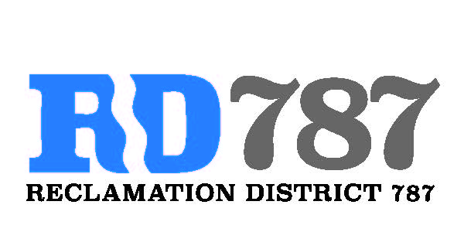

41758 County Road 112. Knights landing CA. 95645. Ph: 530 735-6274. Fax: 530 735-6734

**Special Board Meeting**

**March 3rd, 2020**

**9:00 pm**

1. Call to Order.
2. Approval of Agenda for March 3rd, 2020 Special Board Meeting
3. Open Public Forum.
4. Approve Resolution NO. 20-01, Water Smart Grant proposal to meter the RD 787 discharge pumping stations and integrate with River Garden Farms SCADA system.
5. Adjourn