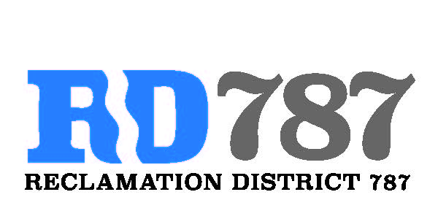

41758 County Road 112. Knights landing CA. 95645. Ph: 530 735-6274. Fax: 530 735-6734

**Board Meeting**

**April 9th, 2021**

**7:00 am**

1. Call to Order – 7:00 am Chairman Roger Cornwell called the meeting to order

* Present were: By Zoom meeting

Board Members: Roger Cornwell, Joseph Hutchins, Eric Faye

Attorney: None

Public: Dominic Bruno

1. Approval of Agenda for April 9th, 2021
   * Additions to Agenda – no additions to the agenda

* Eric Faye made a motion to approve, second Joseph Hutchins– motion passed unanimously

1. Open Public Forum – Dominic Bruno did not present anything.
2. Approval of the minutes from April 20th, 2020 board meeting.
   * Joseph Hutchins made a motion to approve, second Eric Faye – motion passed unanimously
3. Approval of Resolution NO.21-01, Notice of exemption for Maintenance
   * Eric Faye made the motion to approve, second Joseph Hutchins – motion passed unanimously.
4. Approval of Resolution NO. 21-02, authorizing a proposal for funding for 2022 FMAP funds and designating the chairman as representative to execute the FMAP agreement.
   * Joseph Hutchins made a motion to approve, second Eric Faye – motion passed unanimously.
5. A public hearing was opened by Chairman Roger Cornwell to discuss River Garden Farms water transfer to San Luis Delta Mendota Water Authority. The documents do show that River Garden Farms could transfer up to 16,000 acre feet of water. The hearing was held open for 10 minutes without any public comment. The hearing was closed by Chairman Roger Cornwell at 7:45.
6. Adjourn meeting at 7:46 am.